Sales and Marketing // Development Process

Heloisa Eugenio

The task was to create a wireframe from the homepage for the company and post 3 pictures on social media, apart from this it was discussed and decided in the group how would look the homepage, the process wasn't long it took at least 1 day to get the final project.

However, everyone in the group had a different expectation about how the homepage would be, so the only way to everyone agree would be to give as many ideas as possible and talk about which one was better for the creation of the homepage.

WEBSITE WIREFRAME

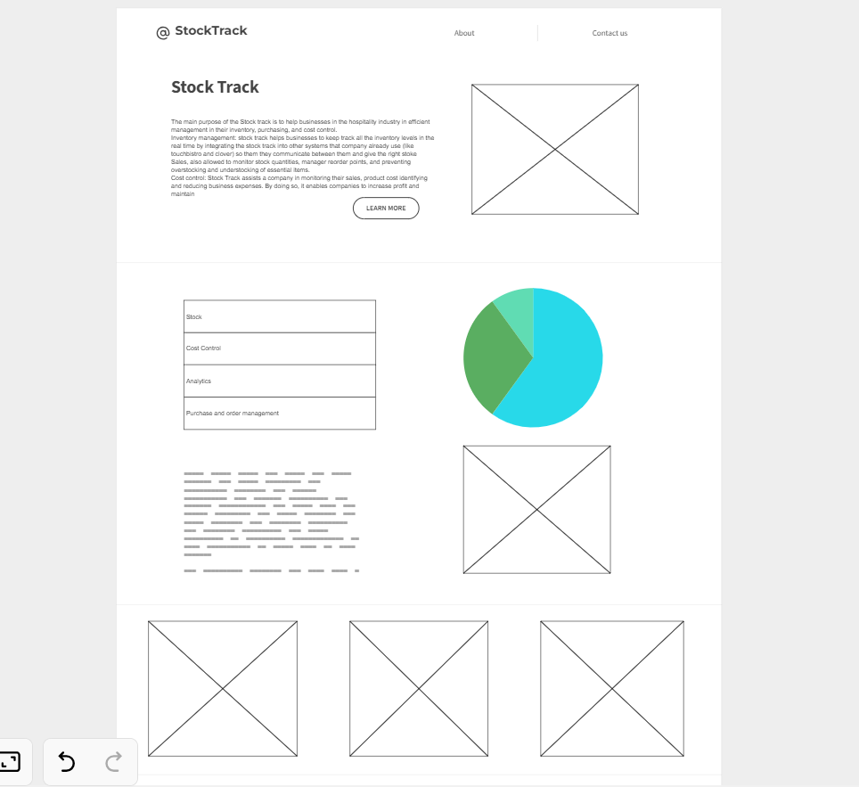

The process of creating the website was simple, most of the space was in white it was decided to add analytics photos to show users the improvement, and texts were also important for the website to explain what is about it and let them update.

INSTAGRAM ACCOUNT

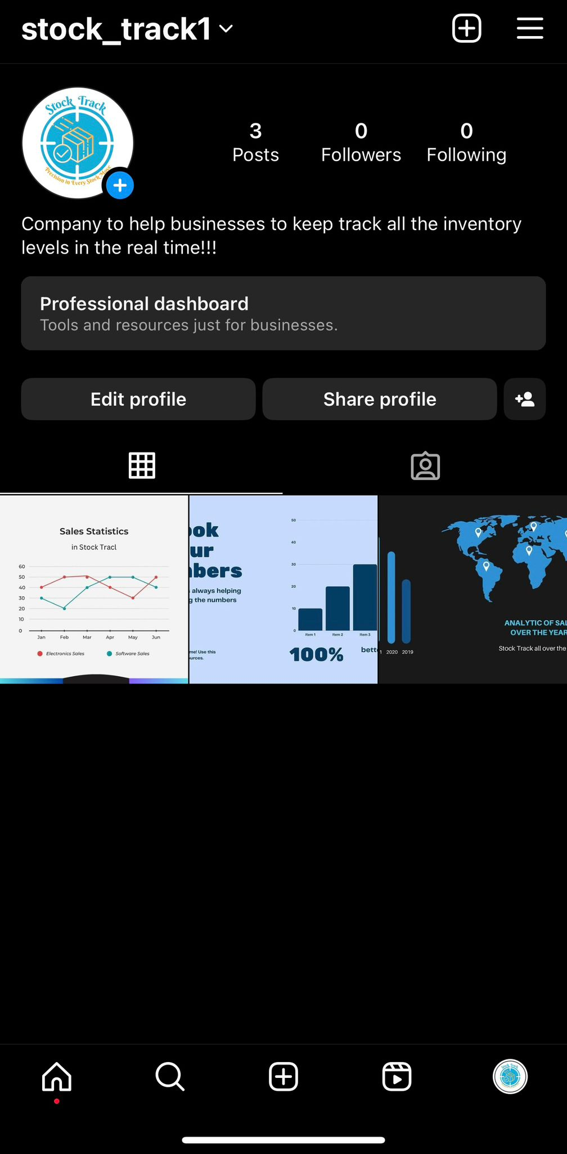

The social media chosen was Instagram the fact that it is easier to use and edit, and the name of the company (StockTrack) was the username to log in. The 3 posts were all about analytics and a few texts on it to explain what is relevant.

SOCIAL MEDIA CALENDAR

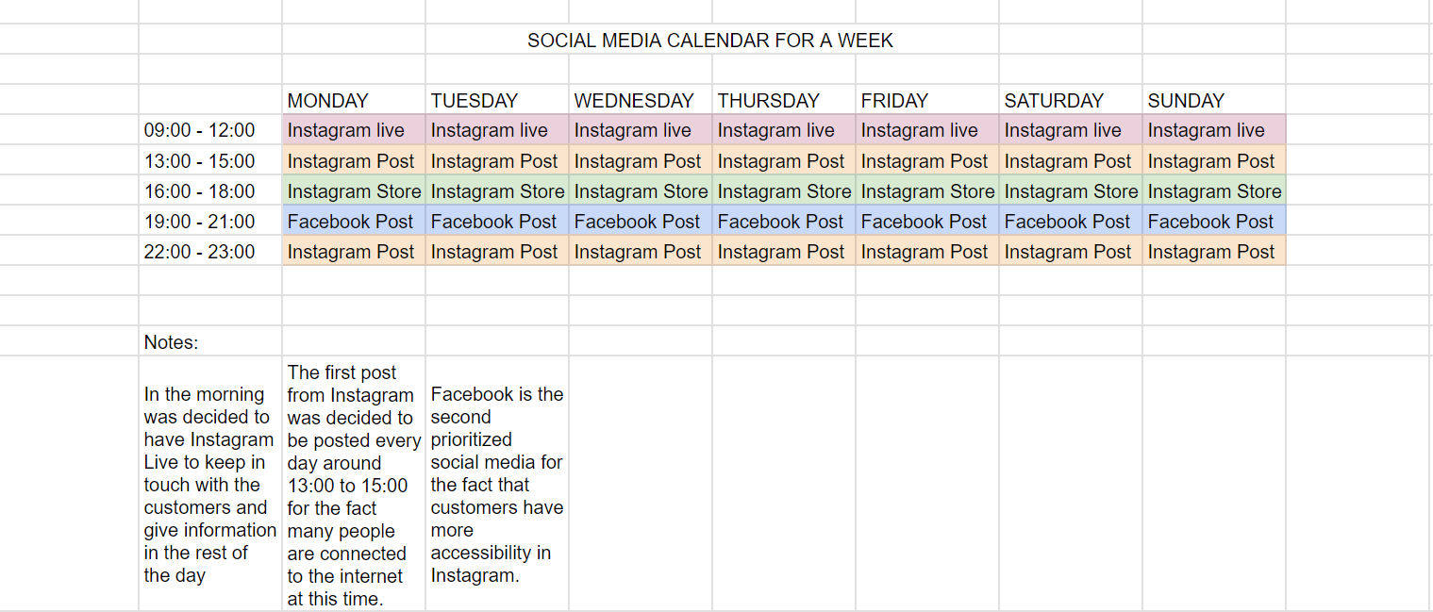

SELF REFLECTION ON CA

Working in a group sometimes can be pretty difficult because of the fact many people with many different opinions, however, this CA was a good exercise to improve my group skills, and one of the reasons it made the homework much easier was everyone in the group have the same nationality and speak same mother language.

The CA, in general, wasn't hard, I guess the difficult part was agreeing with everyone in the group and having to discuss everything. The skill I had to solve problems was to talk about any problem and try to make a deal with my partners.